Name: Pranali Sonawane
Subject: MCSA
Date: 4-12-2025
Lab: Active Directory
- Open Server1 Download Active directory:
Add roles and Features next next Server Selection Server Role Select
1. Active Directory Domain Service
2.DNS Server next automatically select(group policy Management ) Confirmation install
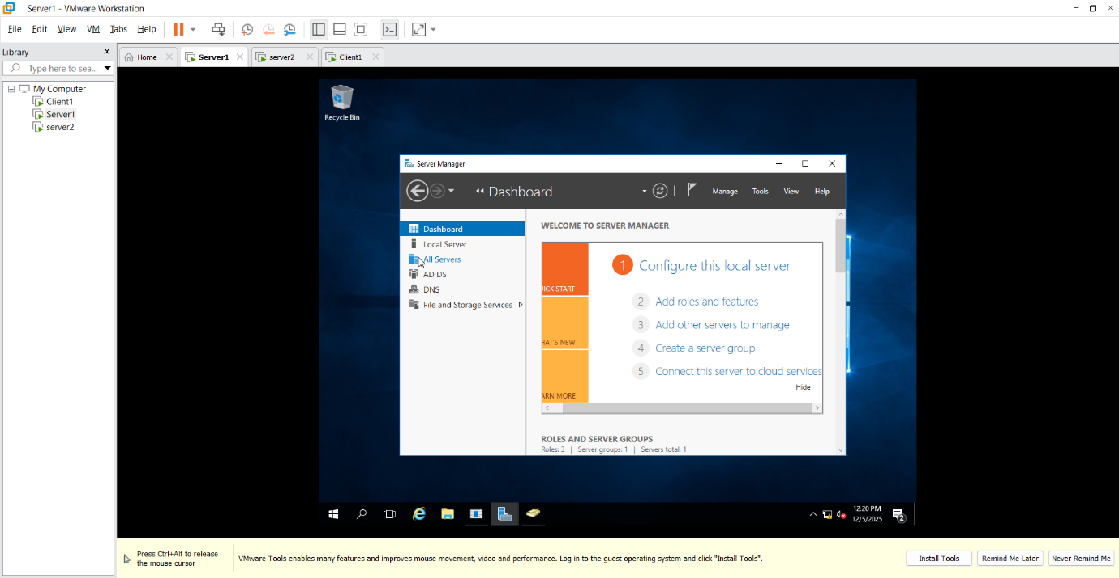
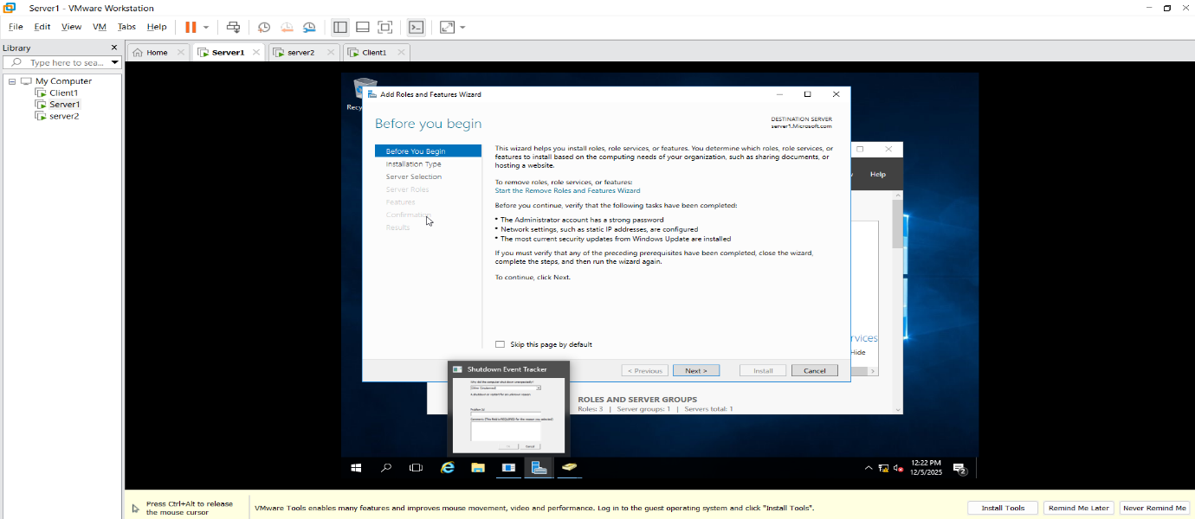
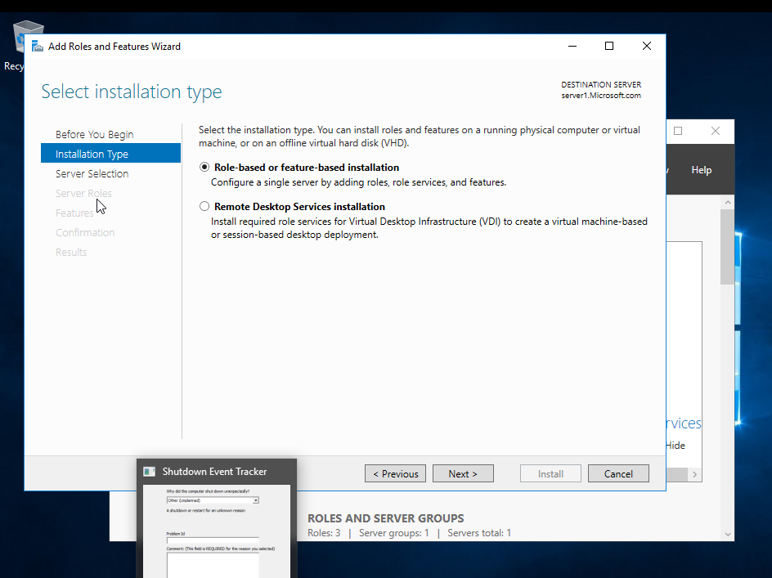

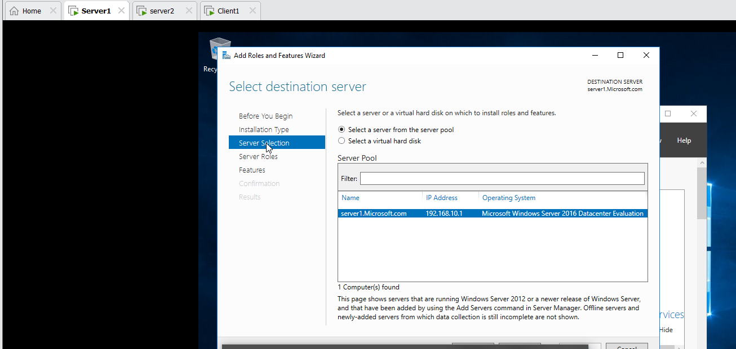
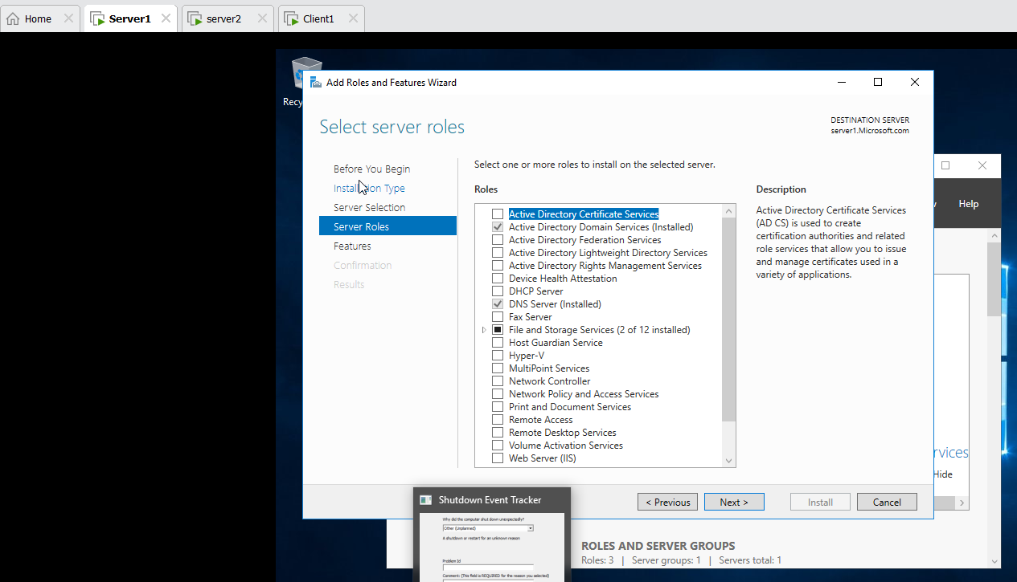
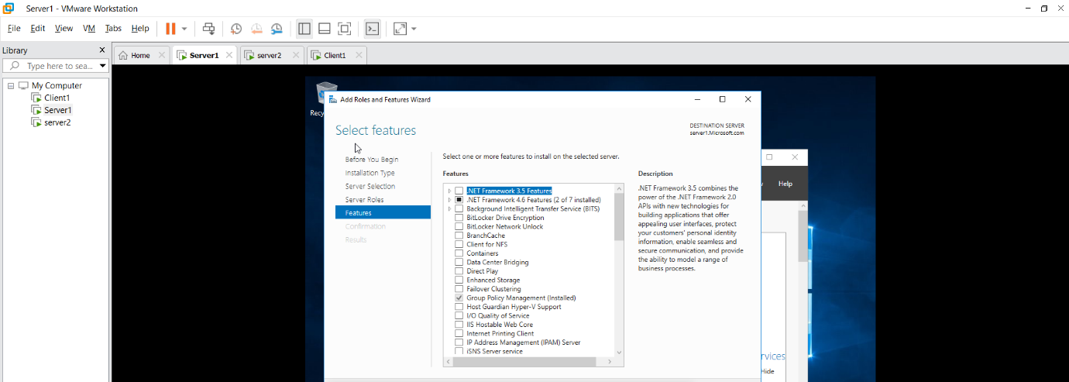
- Go to the Deployment Operation:
Add a new router root domain name : Microsoft.com
Problem Domain Controller Options Password@123 next next NETBIOS Domain Name : MICROSOFT

- First Check Server1,Server2 and Client1 ping to each other.

- Server2 Local server Workgroup change Domain Microsoft.com username(Administrator) Password(Password@123)

- Client1 System Advanced setting name DomainchangeMicrosoft.comusername(Administrator) Password(Password@123)

- Server1 Local server Workgroup change Domain Microsoft.com username(Administrator) Password(Password@123)
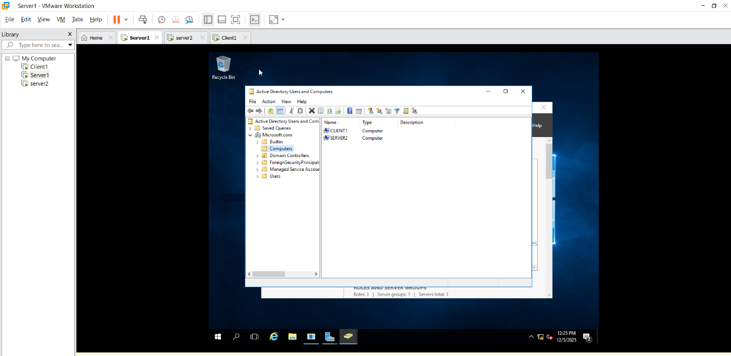

7.Server1 Tools Active directory user and computers Microsoft Users Right click on User 3 user create same as go to the users 4 group create(each group has 3 users)
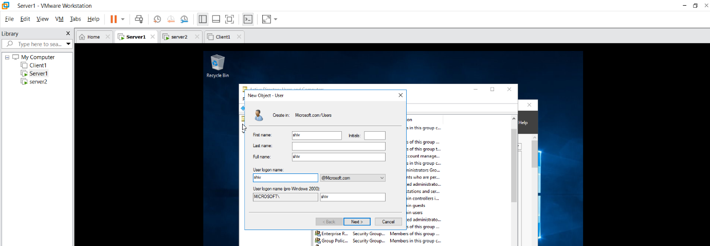

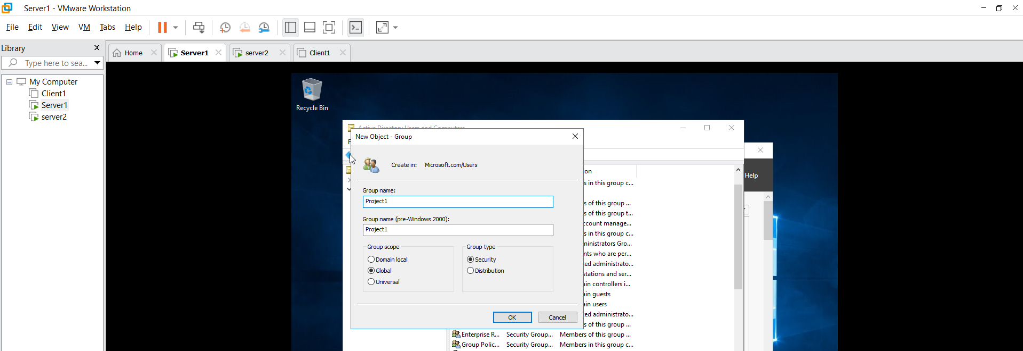

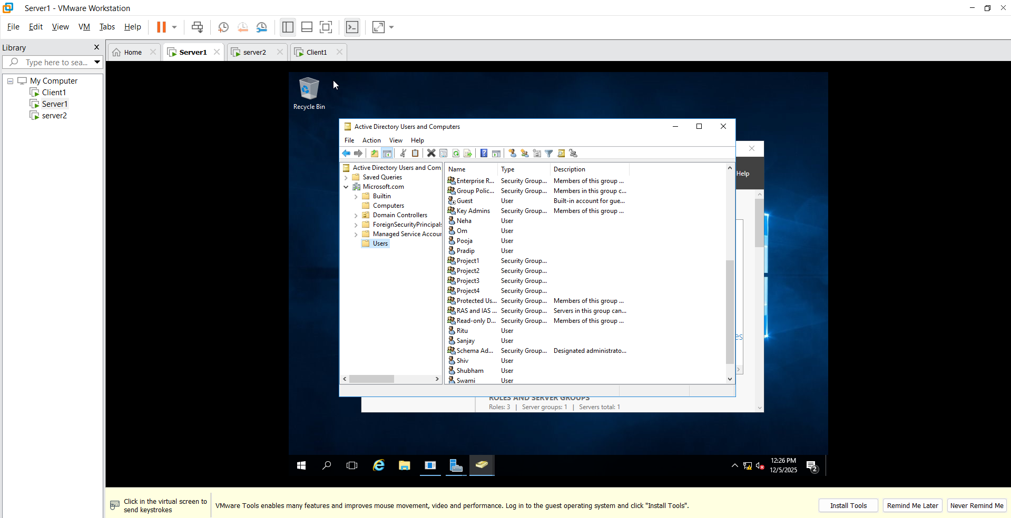

8.Power on Server2 VM other user login by username and Password (in server1 create user add name and password
9.Power on Client1 VM other user login by username and Password (in server1 create user add name and password

